Lab Report Form
Name: ____________________________________ Date: ____________
Partner(s): _____________________________________________________________________
Title: _________________________________________________________________________
Purpose/Problem: The purpose/problem of this lab is ____________________________________________________________________________________________________________________________________________________________
Hypothesis: ____________________________________________________________________________________________________________________________________________________________
Materials: ____________________________________________________________________________________________________________________________________________________________
Procedure:
- _________________________________________________________________
- _________________________________________________________________
- _________________________________________________________________
- _________________________________________________________________
- _________________________________________________________________
- _________________________________________________________________
- _________________________________________________________________
- _________________________________________________________________
- _________________________________________________________________
- _________________________________________________________________
- _________________________________________________________________
Data Collected:

Conclusion: State whether your hypothesis was accepted or refuted. Explain the reason for having so many different structures working together to complete one job (digestion).
___________________________________________________________________________________________________________________________________________________________________________________________________________________________________________________________________________________________________________________________________________________________________________________________________________________________________________________________________________________________________________________________________________________________________________________________________________________________________________________________________________________________________________________________________________________________________________________________________________________________________________________________________________________________________________________________________________________________________________________________________________________________________________________________________________________________________________________________________________________________________________________________________________________________________________________________________________________________________________________________________________________________________________________________________________________________________________________________

Name___________________________________________ Per.____
Lab: Measuring the Monstrous Digestive System
Mr. Mayer

Background:
You feel hungry because your brain receives signals that your cells need energy. But eating is only the beginning of the story. Your body must change a meal into substances that you can use. Your digestive system is a group of organs that work together to digest food so that it can be used by the body.
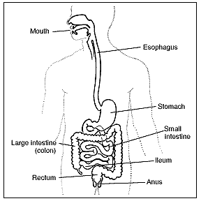
Look at the picture to the right of your digestive system. This system contains many parts & many of the parts are folded up inside your body. If you were to take your digestive system out of your body and lay it out flat, it would surprise you how long it is. In this lab you will make models of your own digestive system by measuring & cutting yarn to represent lengths of different parts of the system, and knotting the pieces of yarn together to from one long string.

Materials: meter sticks, yarn (blue, red, green, yellow, purple), scissors, digestive system diagram

Procedure:
__1) Digestion begins in the mouth, so measure and cut a piece of red yarn from the front to the back of the mouth. (You can do this by stretching the yarn from the front of your lips to the back of your jaw along your cheek).

__2) Record this length in centimeters (cm) in the data table on the next page.

__3) The esophagus is a tube that connects the mouth and stomach. Measure & cut a piece of blue yarn the length of the esophagus. (Measure from your mouth to just below your rib cage). Tie the blue esophagus to the red mouth.

__4) Record the length of this blue string in centimeters (cm) in the data table on the next page.

__5) In the stomach, gastric juices break down solid food into a liquid. Find the length of the stomach by spreading the fingers of your hand and measuring the span from the thumb to the little finger. Measure and cut a piece of green yearn to match this length. Tie the green stomach to the blue esophagus.

__6) Record the length of this green string in centimeters (cm) in the data table on the next page.

__7) The small intestine is the longest part of the digestive system. It is folded up inside of you so it fits. Food is further digested and absorbed here. Measure your heights and multiply it by four. Use yellow yarn to represent the length of the small intestine. Tie the yellow small intestine to the green stomach.

__8) Record the length of this yellow string in centimeters (cm) in the data table on the next page.

__9) Last is the large intestine. It is much wider than the small intestine but much shorter. It is about as tall as you are. Undigested material form the small intestine moves to the large intestine before it leaves your body. Use purple yarn to represent the length of your large intestine. Then tie the purple large intestine to the yellow small intestine.

__10) Record the length of this purple string in centimeters (cm) in the data table on the next page.

__11) Label each segment of your digestive system model with masking tape like your teacher showed you.

DIGESTIVE ORGAN | LENGTH (CM)
Mouth

Esophagus

Stomach

Small Intestine

Large Intestine

Enzymes

Enzymes are a key part of breaking down large molecules ingested by the digestive system. In order for an enzyme to complete its job, the enzyme must fit the substrate at the binding site. Below select the substrate that this enzyme is meant for. After you have made your selection, draw enzymes to fit the other three substrates.

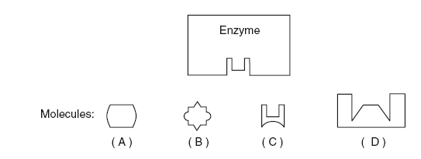

Follow-up Questions:

- What is the TOTAL LENGTH of your digestive system? ______________________ cm

2) Why do you think your digestive system is so long? _________________________________________________________________________________________________________________________________________________________________________________________________________________________________
___________________________________________________________________________
___________________________________________________________________________

- Read back through the procedure. What are the jobs of the following digestive organs?

DIGESTIVE ORGAN | FUNTION (JOB)
Mouth

Esophagus

Stomach

Small Intestine

Large Intestine

1. An enzyme and four different molecules are shown in the diagram below.

The enzyme would most likely affect reactions involving

(1) molecule A, only (2) molecule C, only (3) molecules B and D (4) molecules A and C

2. Base your answers to questions 2 through 4 on the diagram below that represents a human enzyme and four types of molecules present in a solution in a flask.

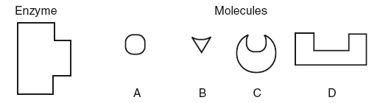

Which molecule would most likely react with the enzyme?

3. Explain your answer to question 2. What principle about the way enzymes work does the question illustrate?

4. Match the enzymes with their substrates and functions.

A. amylase | 1. | synthesizes DNA
B. protease | 2. | digests sugar in beer (maltose)
C. lactase | 3. | digests starch (amylose)
D. DNA polymerase | 4. | synthesizes ATP
E. maltase | 5. | digests milk sugar (lactose)
F. ATP synthase | 6. | digests proteins

5. Base your answers to the following questions on the graph below and on your knowledge of biology.

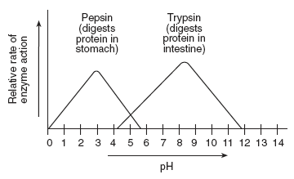

6. What is the optimal pH for pepsin?

7. Is this pH acid or basic?

8. In what organ of the digestive system does pepsin work?

9. What is the optimal pH for trypsin?

10. In what organ of the digestive system does trypsin work?

11. Is this pH acid or basic?

12. Neither enzyme works at a pHs of

